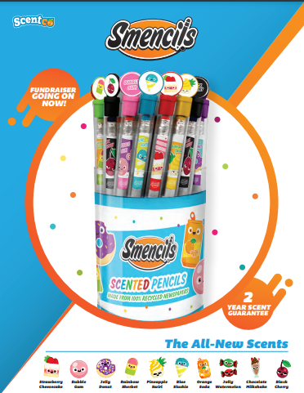

**5th Grade Student Council**

**Smencils Fundraiser**

**10 Different Scented Pencils**

**$1.00 per pencil**

**Please support our 5th Graders**